Pizza sales SQL queries
KPIS
- Total Revenue

SELECT SUM(total_price) AS Total_Revenue FROM pizza_sales;
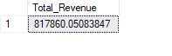
- Average Order Value
SELECT (SUM(total_price) / COUNT(DISTINCT order_id)) AS Avg_order_Value FROM pizza_sales

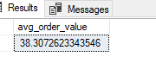
- Total Pizza Sold
SELECT SUM(quantity) AS Total_pizza_sold FROM pizza_sales

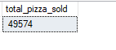
- Total orders
SELECT COUNT(DISTINCT order_id) AS Total_Orders FROM pizza_sales
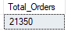
- Average pizza per order
SELECT CAST(CAST(SUM(quantity) AS DECIMAL(10,2)) / CAST(COUNT(DISTINCT order_id) AS DECIMAL(10,2)) AS DECIMAL(10,2))AS Avg_Pizzas_per_order FROM pizza_sales

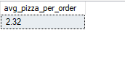
- Daily trend for total orders
SELECT DATENAME(DW, order_date) AS order_day, COUNT(DISTINCT order_id) AS total_orders FROM pizza_sales
- GROUP BY DATENAME(DW, order_date)

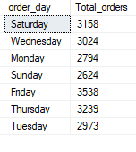
- Monthly trend for total orders
select DATENAME(MONTH, order_date) as Month_Name, COUNT(DISTINCT order_id) as Total_Orders from pizza_sales
GROUP BY DATENAME(MONTH, order_date)
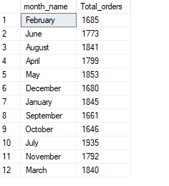
- Percentage sales by pizza Category
SELECT pizza_category, CAST(SUM(total_price) AS DECIMAL(10,2)) as total_revenue,CAST(SUM(total_price) * 100 / (SELECT SUM(total_price) from pizza_sales) AS DECIMAL(10,2)) AS PCT FROM pizza_sales
GROUP BY pizza_category
